**About Us**

Sainand is growing marketing and trading company. We are continuously working towards bringing amazing products at very reasonable prices. We adopted model of Direct selling to save various marketing costs that are added to the product and ultimately makes the product more expensive. Lot of money goes towards advertisements, distributor and dealer commissions, logistics etc. Direct selling saves much of this. In Direct Selling, this saved amount is shared with direct sellers in a defined manner. We are purchase products directly from manufacturers, having our own product testing team and we provide directly to our customer at very reasonable prices.

## PRODUCT

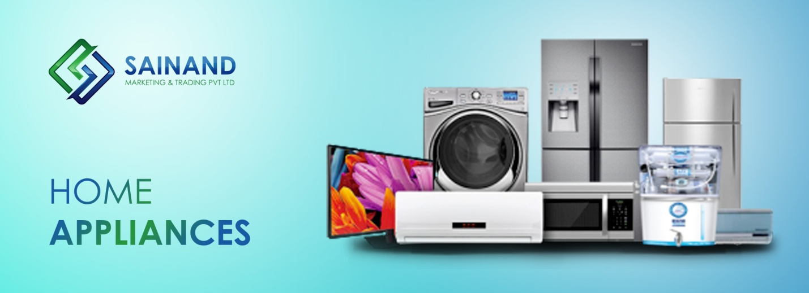

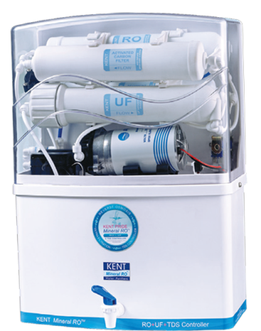

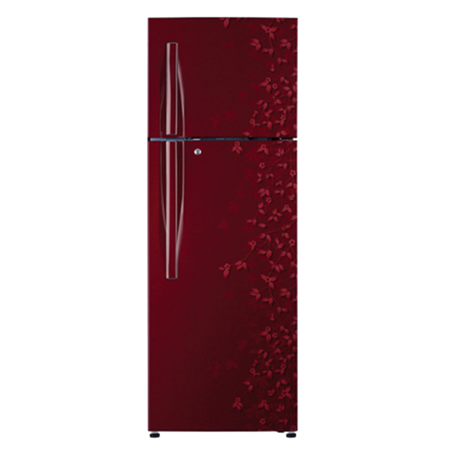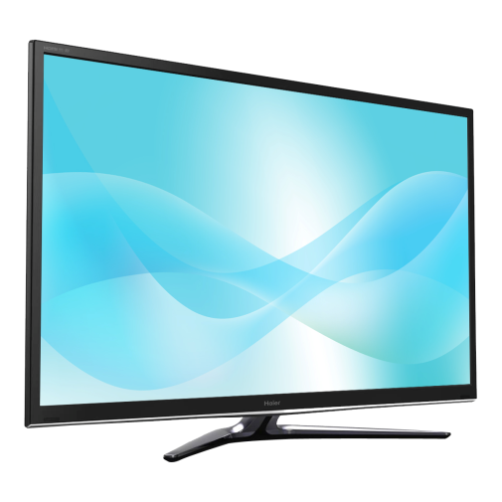

## LEGAL DOCUMENTSE:\Rishi\logo\banner sainand\05.jpg

